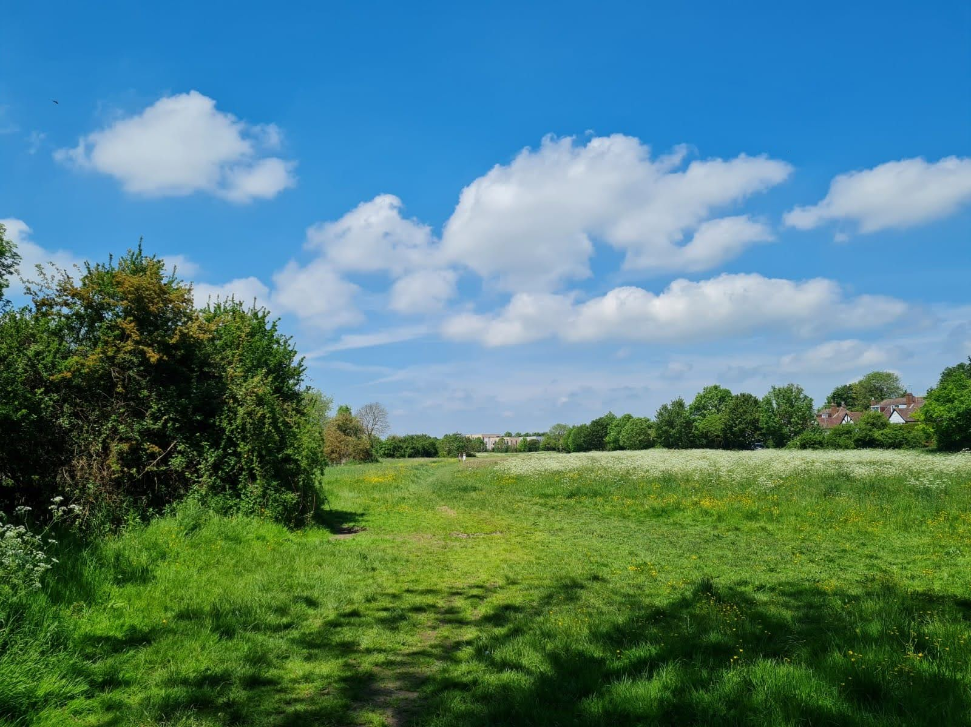

Purwell Meadows
Local Nature Reserve
GREENSPACE ACTION PLAN, 2022 - 2027

BRIEFING DOCUMENT

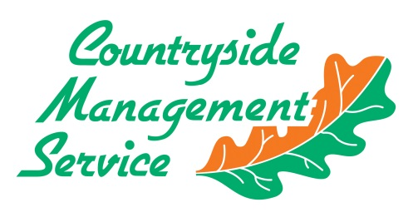
Produced by: On behalf of:

Contents
1. Introduction 2
2. Background 3
3. Review of Progress 5
3.1 Which aims were achieved? 5
3.2 Which elements could have worked better? 6
3.3 What ongoing challenges have we identified? 7
4. Greenspace Action Plan (GAP) 2022-2027 9
5. Community Engagement and Plan Production Process 10
6. Stakeholder Feedback 12

Introduction
A new five-year Greenspace Action Plan (GAP) is being produced for Purwell Meadows. This briefing document provides an overview of how the GAP will be produced and sets out how stakeholders can contribute to shaping the plan.
GAPs are essentially map-based management plans that provide focus and direction for the running and improvement of open spaces. They provide a clear, logical process to determine the activities that should take place over a stated period of time to achieve the objectives for the site.
The GAP is being produced by the Countryside Management Service (CMS), part of Hertfordshire County Council’s Countryside and Rights of Way Service, on behalf of and in partnership with North Hertfordshire District Council. The completed document will inform the management actions to be undertaken over the next five years, commencing in April 2022.
Engaging communities is integral to the production of GAPs, to ensure that stakeholders are fully aware of and able to interact with the plan production process. This briefing document initiates and supports this community engagement.
The engagement period will run from 4th October to 1st November 2021. A further engagement period in January 2022 will provide an opportunity to assess the draft version of the GAP. Please use the contact details in Section 6 to comment on the aspirations for the site.
This document has been broken down into easy to read sections:
Section 2 provides an overview of the site and location map.
Section 3 reviews recent management of the site.
Section 4 contains the core objectives for the Purwell Meadows GAP.
Section 5 summarises the public engagement methodology, setting out how and when stakeholders can contribute to the plan.

Background
Purwell Meadows Local Nature Reserve is an 8.5 hectare (21 acre) open space in the centre of Hitchin, which is owned by NHDC and managed in partnership with the CMS.
The mosaic of dry grassland, marshy grassland, hedgerows and scrub along the river at Purwell Meadows are home to a wide variety of plants, birds, animals and insects. The site is part of a chain of important wildlife areas along the Purwell Valley linked by the River Purwell. The meadows provide a “steppingstone” for the movement of wildlife along the valley such as Water Voles and Otters. The clear, mineral rich water of the river keeps the low-lying land of Purwell Meadows damp, creating marshy wet grassland and wet hollows which support a rich and distinctive variety of wildlife.
Springs rise out of the chalk bedrock at St. Ippolyts, flowing down Ippollitts Brook, joined by other springs to form the River Purwell. Chalk Rivers are a rare habitat globally and in the UK, making the River Purwell of worldwide importance. The site is designated a Local Wildlife Site and was declared a Local Nature Reserve in 1994.

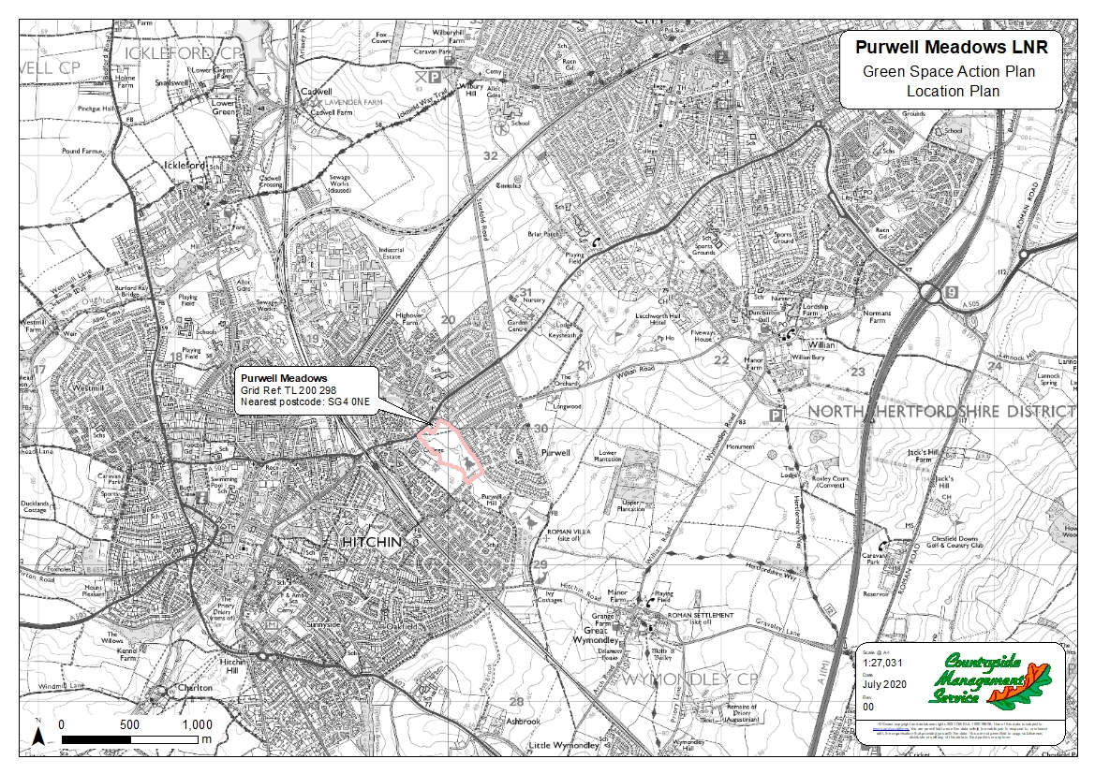

Review of Progress
Over the last 5 years the Purwell Meadows GAP has been implemented successfully in some areas. Funding and the licences required were obtained for the main improvement project within the site. Overall, the objectives set out in the GAP were partly achieved but there were some challenging obstacles.
The following section poses a number of questions and answers to show where the plan has been successful, in what ways it could have been improved, and what the process has taught us about moving forward, with particular regard to the ongoing challenges faced.

3.1 Which aims were achieved?
The overall aim to “improve and enhance the Local Nature Reserve for both wildlife and people” has been partially achieved. Of particular concern is that the site has regressed in terms of biodiversity over the last five years. Reversion of this regression must be a priority for the forthcoming management plan. The aims of biodiversity improvements will remain at the core of the new GAP, incorporating some and adapting others.
a. Wildlife, Landscape and Historic Environment Benefits
The open nature of the meadows has been maintained on the northeast side of the River Purwell through grazing and cutting for hay. The area of meadow to the southwest of the River Purwell had changed with development of more scrub and ruderal vegetation.
Laid out below are key habitat improvements:
River restoration
Sections of the banks that were becoming badly eroded by the action of poaching by cattle have been fenced and are now re-vegetating. This process should be continued along the channel where required. Some tree work was carried out to remove trees from specified sections of both channels through coppicing and pollarding.
Wetland
Some of this area has been cut with arisings removed and cattle encouraged to graze this area by taking a hay crop from the lusher drier side prior to grazing. The new scrape had continued to be allowed to vegetate creating a great habitat for wildlife. Removal of trees on the western boundary through coppicing and pollarding has been carried out.
Hedgerows
The hedgerows along Purwell and Willian Road are establishing well and the hedgerow along Chaucer Way has grown well and could be laid over the course of the next management plan.

b. Providing a Welcoming, Safe and Well-Maintained Space
Existing provisions for visitors have been maintained and enhanced where necessary including surfacing of pedestrian entrance gates. Interpretation panels and the presentation of the site have been maintained to encourage visitors to visit the site.
c. People
Community involvement and access
CMS have led several volunteer sessions on site, involving local people to contribute to the work that is required. Work has included scrub clearance, entrance surfacing, vegetation cutting and removal, Himalayan Balsam control and hedge maintenance. Contacts established through previous engagement have become a very valuable local group of volunteers.
d. Sustainability
Ongoing maintenance
Current management operations through grounds maintenance contract include, management and maintenance of the paths surface and signage, grassland management, litter picking, fly tip removal and reactive tree works to address safety issues.

3.2 Which elements could have worked better?
Access for management
The wet nature of the site makes access with vehicle and machinery during the winter months very difficult. Mechanical scrub removal has been carried out and needs to be carried out in the winter months, access to the area of scrub can be difficult because it needs to be carried out during the wettest months. The work of de-culverting the pipe from Willian road initially was delayed because of not being able to carry out the work during the winter months.
Grazing Regime
Grazing is an important tool for managing the grassland and wetland habitats on site, ensuring scrub is kept in check, breaking up the dominance of particular vegetation species and providing structural diversity. Over the period of the past management plan the grazier has not been able to fulfil the commitment to grazing for the annual period specified. As a result, the area of scrub has expanded, and the grassland biodiversity had deteriorated. A committed grazier is needed to get the site to be in a better condition over the period of the next management plan. Careful management of the timing and levels of grazing on site is important to maximise the benefits and to return the habitats to favourable condition, whilst ensuring poaching, overgrazing and bank erosion is kept to a minimum.

De-culverting project
External funding was granted from the Environment Agency as part of a Water Environment Grant (WEG). This project required licences, which were obtained from Anglian Water to carry out the de-culverting. Some elements of the project were achieved including carrying out some initial tree works along the channels and construction of some in-river deflectors. However, the planned project to de-culvert the pipe from Willian Road to the River Purwell could not be carried out. The initial WEG ran out in March 2021 but it was extended to March 2022 to allow the work to be carried out during summer 2021. However, the local grazier objected to the work being carried out and an agreement could not be reached with the grazier before winter 2021 to 2022, where the time limit of the funding would run out.
3.3 What ongoing challenges have we identified?
Water Quality
The River Purwell has a number of surface sewers which feed into it directly on site and at points upstream, these bring with them contaminants from road run off e.g., oil and other pollutants. The drains also wash a variety of litter into the river including small plastic and metal items e.g. drinking cans. These factors combined affect the water quality within the river and water table which in turn affect condition of the wildlife habitats of the meadows. The balancing pond should provide an opportunity for sediment and pollutants to be removed from the watercourse. However, due to this being full of sediment, the effectiveness of this to remove pollutants is non-existent.
Sustainable grazing
Grazing on the site over the past 5 years has not been up to the standard required to successfully control scrub growth and ruderal species. There has been a clear decline in the quality of the grassland on both sides of the river. Grazing is an important management tool for the site but must be managed more clearly over the course of the next plan to encourage improvements to the site. Meadows like this are generally less appealing to graziers but for this site the economic viability of this management must be maintained.
River Restoration
The River Purwell consists of two channels through the southern half of the site, the one to the east is understood to be the old mill channel which returned water to the main River Purwell after passing through Purwell Mill, this now carries the majority of the water flow. The original river channel to the west has low flow due to an impoundment at Purwell Mill when it ceased use in the 1960’s.
The southern half of the original river channel is heavily silted up due to low flow and the water sources. This channel is also heavily shaded for much of its length through this section. This river habitat is in poor condition as a result.
The old mill channel has good flow with some areas where silt deposition is high. The riverbanks will continue to be susceptible to erosion which is been exacerbated through poaching from livestock. This however does create opportunities for diversification of the river channel particularly the old mill channel which is in the main quite similar in profile and depth for much of its length. If poached areas are given the opportunity for vegetation to re-establish/recover naturally they can stabilise the bank and with natural water action create a more varied river channel that benefits wildlife e.g. young fish refuge areas.
Pressures on Water
Pressure on water resources within Hertfordshire are high due to high usage for drinking water supplies and increase in demand placed by future population & development growth. The same chalk aquifer that supplies drinking water also feeds wetland features e.g. the spring pool called Shadwells and the river that runs through the site, making them particularly susceptible to drinking water abstraction and periods of low rainfall. The recent wet winters have recharged the system for a time, but the habitats and species that can be found here are always susceptible.
Invasive Species
Himalayan Balsam can be found now occasionally on site, due to the concerted efforts of local volunteers it has largely been eliminated. This work will need to continue to ensure the river system continues to be largely free of this and other invasive species. Most of the remaining Himalayan Balsam is located directly next to the river channel so it is very difficult for volunteers to safely remove this.

Greenspace Action Plan (GAP) 2022-2027
The Purwell Meadows GAP 2022-2027 will be a simple, easy to read plan for use by officers of North Hertfordshire District Council and members of the public and will act as a guide to the work of volunteers. The plan will be largely map based, with sequential, annual management maps to show the actions planned for each year. The resulting change will be represented on the map for the following year. The document will be reviewed annually to ensure it remains effective and relevant.
The plan will be costed, and potential funding sources identified. Once the final GAP is agreed, external funding will be sought to enable the plan to be delivered.
The aim and objectives of the GAP will be as follows:
Aims
The aim of the Purwell Meadows GAP is to improve the quality of habitats on site and to make enhancements for people visiting the site
Objectives
- To enhance the biodiversity of the site and restore the wet grassland to previous condition.
A1 Ensure that the grazier adheres to the terms of grazing agreement, grazing the site as specified to aid with the improvement of grassland.
A2 Ensure that northeast side of the mill stream is cut for hay before the end of June.
A3 Work with River Purwell catchment partners to improve the water quality of the river.
A4 Continue with a program of scrub control/removal to open up the area of land to the southwest of the site, using mechanical means where necessary and possible.
- To promote awareness and engagement in Purwell Meadows LNR
B1 Ensure that any events or volunteering opportunities are well advertised locally and on NHDC website.
B2 Promote new GAP on the NHDC website and engage stakeholders in the production process.
B3 Over the course of the next GAP the interpretation will need updating.
- Provide a green space that continues to be welcoming, safe and well maintained
C1 Continued maintenance of paths, signage and footpath furniture.
C2 Regular litter picking and responses to misuse of the site.
C3 Ensure that tree inspections and reactive tree works continue to be carried out.
C4 Ensure that the boundary of the site continues to be well maintained to create a welcoming environment (hedges and fences).

Community Engagement and Plan Production Process
Effective community engagement is at the centre of successful management plans. The value of a GAP is maximised when it incorporates and balances the aspirations of stakeholders and interest groups.
In order to provide all interested stakeholders and groups with the opportunity to feed into the production of the new GAP, we have adopted a structured two-stage approach to community engagement.
- For the first stage (this briefing document), stakeholders and site users will be invited to make comment on the core aspirations in Section 4; it is hoped that any further aspirations and/or issues will be identified through this information gathering process. This first stage of community engagement will run between Monday 4th October and Monday 1st November 2021.

- For the second stage, stakeholders and site users will be invited to read through and make comment on the draft GAP, which will include the detailed proposals and actions. This stage is intended to run in between approximately Monday 3rd January and Monday 31st January 2022.
Following the second stage exercise, the final document will be produced, published and the actions will commence.
Please be aware that we will not respond individually to comments received through the public engagements; instead, we will produce a summary of comments, noting any amendments made to the plan as a result. This engagement response document will be published online alongside the briefing document, draft plan and final plan. We will retain contact details only for the purpose of keeping respondents informed about the plan development process.
The diagram on the following page shows the Greenspace Action Plan production process:

Stakeholder
Environment Agency
Upper & Bedford Ouse Catchment Partnership
Herts and Middlesex Wildlife Trust
Anglian Water
Grazing Tenant
Hitchin Forum
Friends of Purwell Valley contacts
Friends of Butts Close
Hitchin Town Centre Initiative
Local Community/volunteers
North Herts District Council
Hertfordshire County Council including:
Highways
Rights of Way
Ecology
Flood Risk Management
Relevant NHDC and HCC Cllrs
Historic Environment Record

Engagement will run from approx.
4th October 2021 to
1st November 2021
Production of briefing document and outline proposals
Engagement will run from approx.
3rd January 2022 to 31st January 2022
Purwell Meadows
GAP
2022-2027
Stakeholder engagement on briefing document
Production of final GAP
Publicity and promotion
Stakeholder engagement on draft GAP
Production of draft GAP

Stakeholder Feedback
Thank you for taking the time to read this document. We are keen to receive feedback from you on our proposals for the Purwell Meadows Greenspace Action Plan (GAP) 2022-2027.
Please return your comments using the contact details below by Monday 1st November at the latest.

FAO Elgan Adlard
Countryside and Rights of Way
County Hall
Pegs Lane
Hertford
SG13 8DN

E-mail: elgan.adlard@hertfordshire.gov.uk

Phone: 01992 588935

