Consultation: How should district councillors for North Hertfordshire District Council be elected?
Introduction
The way you elect district councillors to North Hertfordshire District Council (North Herts Council) is being reviewed. We want to hear from you before a decision is made. Please read this information and complete the survey on SurveyMonkey. Alternatively, please complete the form below to tell us your views and return to:
North Hertfordshire District Council
Council Offices
Gernon Road
Letchworth Garden City
Hertfordshire
SG6 3JF

Or email to: ElectoralCycleConsultation@north-herts.gov.uk

Ensuring that responses are returned by: 8 November 2021

Background
Like all district councils, North Herts Council is divided into electoral wards. These are geographical areas within the council area. The local people who live in a ward are the people who can vote to decide who will represent them on the council. The ward you live in does not affect the amount of council tax you pay or the local services you are provided with by the council.
The warding arrangements for this area are currently being reviewed by the independent Local Government Boundary Commission for England (LGBCE). As part of the review the council have been invited to consider how district councillors are elected in future.
At the moment, district councillors are elected ‘by thirds’. This means that one-third of all the councillors are elected each year for three years, with no elections to this council in the fourth year (on the fourth year we hold county council elections). Each councillor is usually elected for four years. If we continue to elect district councillors in this way, there will be some changes. These are outlined below.
There is another way that district councillors can be elected. This is known as ‘whole council’ or ‘all out’ elections. This means that every councillor is elected at the same time in one year, usually elected for four years, and no scheduled elections would be in any of the other three years. If we change to this system, there will be some changes. These are outlined below.
What might happen
If we continue to elect district councillors by thirds
All the current wards will be changed. They will be replaced by new wards, which the LGBCE will develop over the coming year (there will be consultations on the proposals, hosted by the LGBCE). Every new ward will have three district councillors. It is likely that most, if not all, existing ward boundaries will be changed. The elections in 2022 and 2023 will continue as normal. In May 2024 the elections would be to the new ward boundaries. All seats would be up for election, with the candidate in each ward securing the highest number of votes elected for 4 years; second highest for 3 years; and third highest for 2 years. In 2025 the scheduled county council elections will take place, and elections to this council will take place by thirds from May 2026.
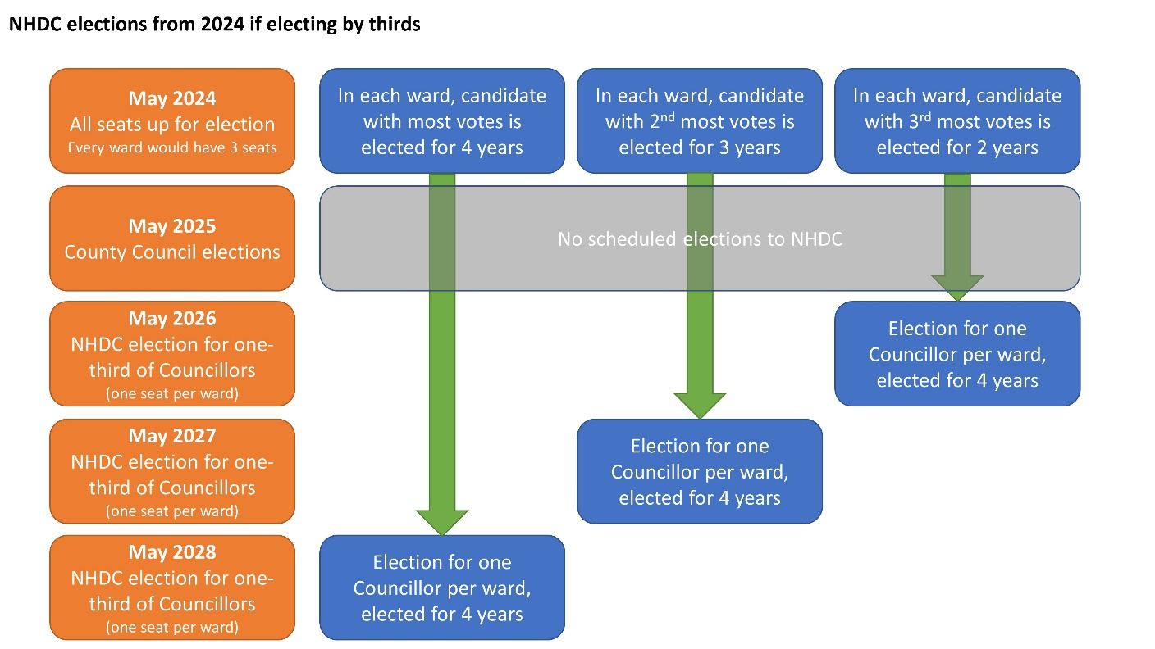

If we change and elect district councillors once every four years
If the council chooses to move to whole council elections, all existing wards will be changed. They will be replaced by new wards, which the LGBCE will develop over the coming year (there will be consultations on the proposals, hosted by the LGBCE). New wards would be for a mixture of 1, 2 and 3 Member wards. Many ward boundaries may be changed. The elections in 2022 and 2023 will continue as normal. In May 2024 the elections would be to the new ward boundaries. All seats would be up for election, with the winning candidates elected for 4 years and scheduled elections to this council every four years. Moving to whole council elections every 4 years reduces the number of scheduled district elections and could save the council money - the precise saving would depend upon whether the district elections were combined with any another election as sometimes costs are shared by central government.

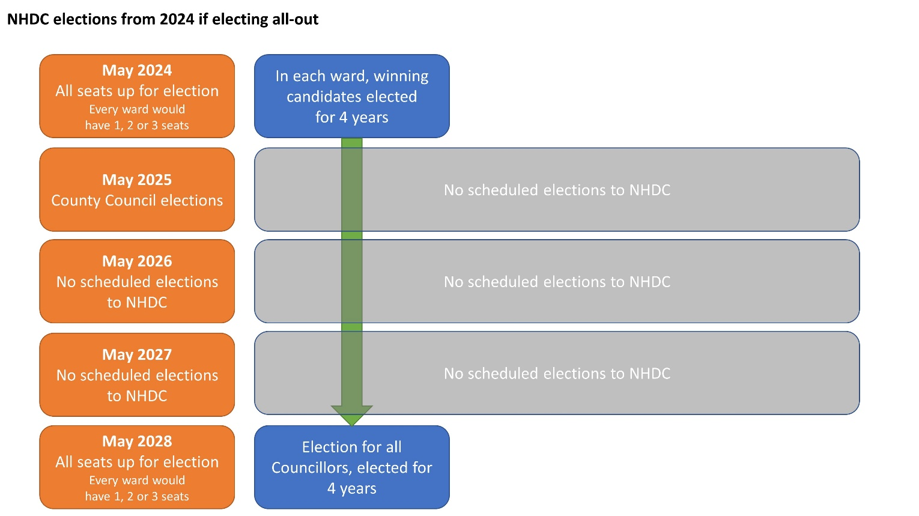
Consultation
We want to hear from you, to find out which option you prefer and why. This will help the council make a final decision later this year.
- Having read the information above, do you think we should: Select one only

  - elect one third of our district councillors every year (‘by thirds’)
  - elect all of our district councillors every four years (‘whole council’/’all out’)

- We would like to understand why people have chosen a particular option, so please tell us why you feel that way? Expressing a reason for a preference is beneficial as it will be considered by Council when a decision is made on whether to maintain electing councillors by thirds or to move to electing councillors once every four years.

- We want to hear from local people within the district, so please tell us the following information:

  - Your name
  - Your postcode
  - Your house name or number
The consultation responses received will be published on the council’s website as part of a report to Council. Your name and address will not be published. This information is collected to identify the areas that consultation responses have been received.

 | If the district council is elected by thirds | If the district council is elected once every four years
May 2022 | Election for one-third of district councillors, on current ward boundaries. District councillors remain in post until May 2024 elections. | Election for one-third of district councillors, on current ward boundaries. District councillors remain in post until May 2024 elections.
May 2023 | Election for one-third of district councillors, on current ward boundaries. District councillors remain in post until May 2024 elections. | Election for one-third of district councillors, on current ward boundaries. District councillors remain in post until May 2024 elections.
May 2024 | New wards take effect, each will have three councillors.  Election for all district councillors. The candidate in each ward with the highest vote is elected for four years, second highest for 3 years, third highest for 2 years. | New wards take effect, each will have one, two or three councillors.  Election for all district councillors. All District councillors are elected for 4 years.
May 2025 | Election to county council | Election to county council
May 2026 | Election for one-third of district councillors, on new ward boundaries. District councillors remain in post for four years. | No election
May 2027 | Election for one-third of district councillors, on new ward boundaries. District councillors remain in post for four years. | No election
May 2028 | Election for one-third of District councillors, on new ward boundaries. District councillors remain in post for four years. | Election for all district councillors. All district councillors are elected for 4 years.

