Meeting Started at 19:30
Attending:
Cllr Barnard (Chair)
Cllr Ralph Muncer (Vice Chair)
Cllr Claire Strong
Cllr Louis Peace
Cllr Mandi Tandi
Cllr Ian Moody

Police Inspector James Lant
Claire Morgan – Community Partnerships Team Leader
4 members of public

CLLR BARNARD welcomed everyone to the meeting and outlined the items on the agenda.

1. APOLOGIES FOR ABSENCE

We have received apologies from.
Cllr Lisa Nash
Cllr Dominic Griffiths
Cllr Faye Frost

No further apologies.

2. CHAIR’S ANNOUNCEMENTS

Members were reminded to make declarations of interest before an item they may wish to abstain from voting if they have an interest, but they are merely making recommendations and not decisions.

3. POLICE SAFER NEIGHBOURHOOD TEAM UPDATE (19:35)
Police Inspector James Lant provided a presentation on the Safer Neighbourhood Team activities in the Southern Rural area outlined below in Appendix 1.
After the presentation Cllr Muncer asked about the level of Prosecutions – James Lant said he’ll look into this and let him know.
Wants to improve the relationship between the Herts and Beds police to help areas such as the Cockernhoe development when that is built.
Cllr Strong suggested more police community engagement by attending the Parish Council meetings – James Lant asked for a list of all the Parish Council meetings dates. A Member of the audience suggested the Herts Association of Parish & Town Councils (HAPTC) Hertfordshire Association of Parish and Town Councils (haptc.org.uk) could provide a list.

Cllr Barnard delivered an update from the North Herts Council Community Safety Team.

- There have been 2 joint agency operations in December and January with police, NHC enforcement officers and VOSA (vehicle operators’ standards agency) held in the Offley area to deter and catch potential fly tippers or unlicensed waste carriers. A few vehicles of interest were stopped, but no prosecutions.
- There have been 2 court cases for fly tipping in Southern rural, since September 2023. The first resulted in a Fine of £200, £700 costs and a £90 victim surcharge. The second was a £50 fine, £100 costs, and £20 victim surcharge.
- There are 3 more court cases for fly tipping in the local area due in March, with 1 offence listed at Luton Magistrates court and the other 2 at Stevenage magistrates. We are hoping for better deterrent sentences than the recent cases.

4. PUBLIC PARTICIPATION IN RELATION TO GRANT APPLICATION
(20:35)

Claire Morgan, the Community Partnerships Team Leader updated Members on budgets?
Community Grant budget available is £5,393. The total amount of funding requested for this meeting is £2,500.

If the application presented this evening is recommended by the Forum and subsequently approved by the Executive Member for Community & Partnerships, there would be £2,893 to carry forward into the 2024/25 budget, subject to approval from Cabinet.

To receive presentations in support of grant applications:

The Chair invited Kelly Metcalf and Esme Harvey from St Paul’s Walden Nursery to present?
Kelly gave a presentation regarding the St Paul’s Walden Nursery about how they work, their building urgently needs new flooring and Ofsted have asked them to rectify this. The group have been undertaking fundraising activities. Comedy night, a grant and £500 from Cllr Barnard Locality budget. If they are successful, this evening they will be £38 short which they will fund from their reserves.
There is a local need for the nursery proven by the fact that two other local nurseries have closed so it’s increased the catchment area of the nursery.

Cllr Strong proposed that the forum provides the additional £38 so that the group did not have to use their reserves.

Proposed by Cllr Strong £2538
Seconded by Ian Moody
5 Members voted in favour.
Cllr Barnard did not vote as he has supported via his Herts County Council locality funding.

Recommended an amount of £2538 to report to the Executive Member in consultation with the Service Director for Legal and Community for final decision.

5. INFORMATION NOTE: GRANTS & COMMUNITY UPDATE
(20:45)

Claire Morgan, the Community Partnerships Team Leader presented an update on her team’s activities in particular the actives of Laura Hartley who covers the Southern Rural area.
• Reaching out to village halls and community centres to gain knowledge on local community groups. Recently met with the manager at Great Ashby Community Centre and the work they do.
• Working with Ickleford Parish Clerk towards addressing loneliness in rural areas. Met with CDA Herts (Community Development Action Hertfordshire) to discuss how to create digital inclusion as part of addressing this and support available in the local area.
• Toured St Ippolyts with Parish Councillors to find out more about the community and local area.
• Attended a school democracy visit for year 5/6 with Cllr Barnard to Cockernhoe Primary School.

6. OPEN DISCUSSION (20:50)

Questions from the floor about any of the agenda items
General Questions or issues anyone wishes to raise.

Discussion – around the effectiveness of Area Forums – Cllr Strong said she wants them all hybrid based at the Council Offices in Letchworth so that people can either attend in person or join via Zoom and it can be broadcast on YouTube for the Parish Councillors to view.

Question from floor about children in Whitwell not getting school places.
Cllr Barnard in his position as Herts County Councillor will set up a meeting with the parents. Cllr Moody said there was an issue in Codicote, and the Stevenage MP supported them.

7. WARD MEMBERS ACTIVITIES (21:00)

No Updates.

8. TOPICS FOR FUTURE FORUMS (21:10)

Cllr Louis Peace suggested a presentation from Citizens Advice.

MEETING CLOSE – 21.20

Appendix 1 – Presentation provided by Police Inspector James Lant

Intro
- Neighbourhood Policing Team Structure
- Local Priorities
- Crime Statistics
- Herts Connected
- Community Engagements
- Rural work

Structure
CI Treadwell
Insp Lant, N Herts NPT Inspector
PS Taz Gill – Hitchin Rural Sgt

GOOD NEWS – Southern Rural PC numbers increased from 3 to 5(66% increase) – only part of North Herts NPT that has been increased. Permanent change. Currently 1 vacancy which is expected to be filled via a recruitment process running right now – that will give us our 5.

CURRENT PRIORTY SETTING FORUM (PSF) PRIORITIES
- ASB/DRUG USE ACROSS HITCHIN RURAL
Increased hi-vis patrols in KIMPTON/ KNEBWORTH and other locations.
Use of ASB legislation against persistent offenders (Op Panther letters, CPW, CPN etc.)
Drug possession offences down in G1 rural by 55% (stats to follow). ASB also down (see stats) so we are seeing positive results.

Specific example (from Media release):
- A derelict building in Hitchin Rural which became an anti-social hotspot has been secured after the intervention of the North Herts Neighbourhood Policing Team (NPT).
The former Offley Oriental building was attracting people who were using the outbuildings situated on the land as places to engage in anti-social behaviour by causing damage to the buildings, smoking cannabis there and dangerously climbing on the roof.
Members of the public reported the issues to NPT officers PC Natasha Redman and PCSO Heather Burrows who worked in partnership with the owners, the parish council and North Herts Council to provide a solution.
PC Redman said: “Every area in Hertfordshire has a locally-based NPT and we focus on local crime and anti-social behaviour (ASB) issues.
“When this ASB was reported we worked with various partners, including the property owners and council, to identify ways to resolve the situation.
“Thanks to the owner having taken action, including securing the main building and taking down the outbuildings, we have not had any further issues reported.”

- FLY TIPPING

Proactive-
Rural op in January (OP OUTWARD), aimed at tackling rogue traders and suspected fly tippers using road network through the village of Lilley. Joint operation with NHC Community Safety, Trading Standards, Motor Insurance Bureau, DVLA, Beds Safer NPT and Herts Rural Operational Support Team. See media release on North Herts Police Facebook page.

More Op Outward operations being planned in Hitchin Rural.

Targeted patrols on various dates across Hitchin Rural including Knebworth and Kimpton.

Plans in hand to run more days of action with NHC as lead agency for fly tipping both at fixed locations (Op Outward) and mobile following intel provided by NHC (hot spot maps).

We will also be running Op Agrarian days of action with ROST and other partners in near future. Details of op from East Herts gives an idea of what it will look like:
Operation Agrarian - Targeting Users Of East Herts Roads | East Herts District Council

Police currently attend all reports of Fly Tipping IN PROGRESS on an immediate response. We have recorded 7 such fly tips over the past year. Of those 7, 6 filed and 1 under investigation.

Monthly fly tip report maps (needed to direct our patrol plans) not currently provided by NHC as lead agency as staff member responsible is absent from office. Hoping this can re-start soon so that increased joint days of action can be arranged with NHC and ROST + Beds NPT as a significant number originate from Luton (cannabis farm rubbish).

- SPEEDING

Various speeding enforcement ops published on our social media page – promote this.
Recent activity to give an idea.:
Holwell op 20th February
Ickleford – 2/2
Luton Road, Offley Feb
St Ippolyts – March (yesterday)
Kimpton – March (yesterday)

All of our activites promoted on our social media pages so worth signing up to follow if not already.

PCC Drivesafe van + volunteers scheme open to all members of the public.
Community Drivesafe (hertscommissioner.org)

CRIME STATS

Compares 1/4/23 – 06/03/24.
1/4/22 – 06/03/23
Year | This Year | Last Year | % Change
G1 Rural | 731 | 755 | -3%
North Herts | 5964 | 6094 | -6%
County | 69655 | 70738 | -2
North Herts
Crimes per 1000 of Population – 38.20
Ave Daily Crimes – 17
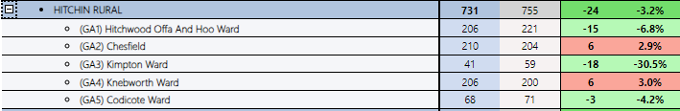
Remember Chesfield covers Gt Ashby (Stevenage)

Burglary Residential - Dwelling
Year | This Year | Last Year | % Change
G1 Rural | 31 | 24 | +29%
North Herts | 151 | 125 | +21%
County | 1810 | 1703 | +6%
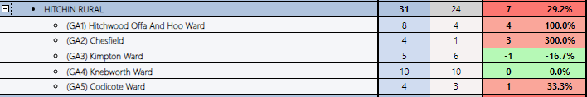
Owl messaging used to improve awareness. Addresses around burgled premises are cocooned. 20 page Op Guardian crime prevention / target hardening pack given to every resident and neighbouring addresses as well. OWL message sent out to residents for every burglary reported giving relevant advice.
G1 rural only have less than 2 per cent of all Herts burglaries but this is an absolutely priority given the increase (albeit from a low number).

Burglary Res – Non-Dwelling (sheds / outbuildings etc)
Year | This Year | Last Year | % Change
G1 Rural | 9 | 18 | -50%
North Herts | 46 | 68 | -32%
County | 712 | 629 | +13%
North Herts (both types of Burglary)
Crimes per 1000 of Population – 1.96
Ave Daily Burglaries - 1
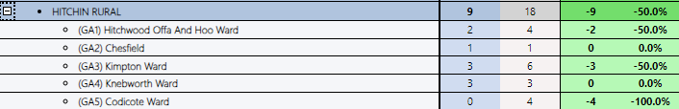

Burglary Business & Community
Year | This Year | Last Year | % Change
G1 Rural | 13 | 18 | -28%
North Herts | 99 | 139 | -29%
County | 1123 | 1164 | -4%
North Herts
Crimes per 1000 of Population – 0.65
Ave Daily Crimes – 0
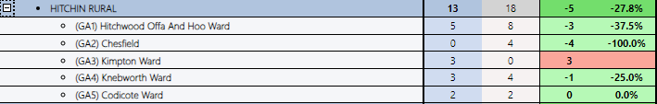

Theft From Motor Vehicle
Year | This Year | Last Year | % Change
G1 Rural | 31 | 30 | -3%
North Herts | 207 | 278 | -26%
County | 3158 | 3869 | -18%
North Herts
Crimes per 1000 of Population – 1.41
Ave Daily Crimes – 1
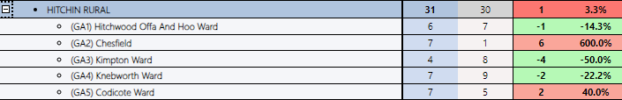

Robbery Personal
Year | This Year | Last Year | % Change
G1 Rural | 2 | 4 | -50%
North Herts | 25 | 27 | -7%
County | 636 | 560 | +14%
North Herts
Crimes per 1000 of Population – 0.15
Ave Daily Crimes – 0
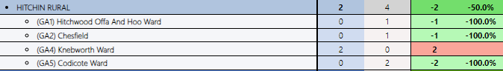

Violence Against the Person (Victim Based)
Includes all victim based – assaults, stalking & harassment, mal comms, etc.
Year | This Year | Last Year | % Change
G1 Rural | 299 | 287 | +4%
North Herts | 2254 | 2249 | +0.2%
County | 24159 | 24948 | -3%
Assaults without Injury = 122 this year. 129 last year.
Assaults with Injury = 88 this year. 79 last year.

Above likely to be driven by higher reporting levels – increased victim confidence

North Herts
Crimes per 1000 of Population – 14.99
Ave Daily Crimes – 7
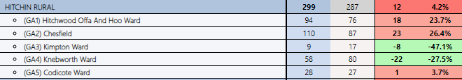

Criminal Damage/Arson
Year | This Year | Last Year | % Change
G1 Rural | 86 | 90 | -4%
North Herts | 702 | 787 | -11%
County | 6951 | 6958 | -5%
North Herts
Crimes per 1000 of Population – 4.76
Ave Daily Crimes – 2
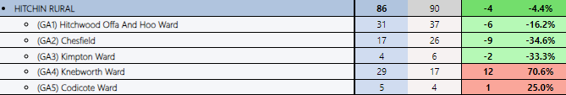

Domestic Abuse Related Crimes
(All DA crime)
Year | This Year | Last Year | % Change
G1 Rural | 167 | 180 | -7%
North Herts | 1027 | 1137 | -10%
County | 10560 | 11539 | -8%
DA crime accounts for:
- 23% of all G1 Rural crime.
- 18% of all North Herts Crime
- 15.2% of all Herts Crime

Sexual Offences (incl. Rape)
Year | This Year | Last Year | % Change
G1 Rural | 42 | 50 | -16%
North Herts | 320 | 332 | -4%
County | 3041 | 3184 | -4%
A significant element will be historic
Shoplifting
Year | This Year | Last Year | % Change
G1 Rural | 45 | 38 | +18%
North Herts | 506 | 430 | +18%
County | 8219 | 6510 | +26%

Increase driven by a single retail location in Knebworth primarily. Shoplifting about to be placed on Herts Constabulary’s Control Strategy which will result in greater focus on this crime type.

North Herts
Crimes per 1000 of Population – 3.55
Ave Daily Crimes – 2
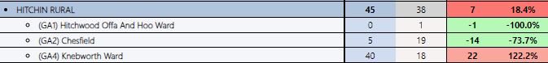

Drugs Possession
Year | This Year | Last Year | % Change
G1 Rural | 9 | 20 | -55%
North Herts | 127 | 152 | -16%
County | 1668 | 1748 | -5%
North Herts
Crimes per 1000 of Population – 0.85
Ave Daily Crimes – 0
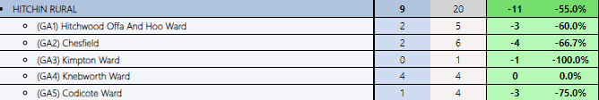

Public Order
Year | This Year | Last Year | % Change
G1 Rural | 42 | 43 | -2%
North Herts | 313 | 373 | -16%
County | 3570 | 4392 | -19%
North Herts
Crimes per 1000 of Population – 2.13
Ave Daily Crimes – 1
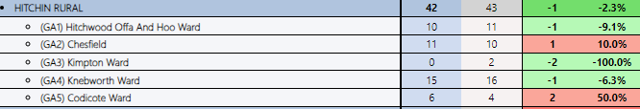

Possession of Weapons
Year | This Year | Last Year | % Change
G1 Rural | 8 | 4 | +100%
North Herts | 40 | 39 | +3%
County | 530 | 511 | +4%
North Herts
Crimes per 1000 of Population – 0.21
Ave Daily Crimes – 0
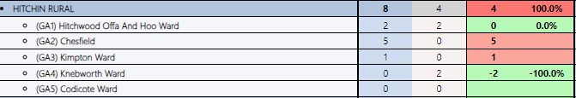

To reassure, Chesfield covers Gt Ashby in Stevenage and we have had several reports involving large groups fighting at a particular venue in Chesfield which explains this increase. No indication of a wider increase elsewhere in the district.

ASB
Year | This Year | Last Year | % Change
G1 Rural | 235 | 290 | -19%
North Herts | 2141 | 2298 | -7%
County | 23694 | 23168 | +2%
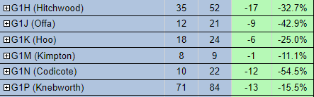
Overall reduction but working with local officers to understand why Cadwell is an outlier as they have seen a significant increase. This ward will be the priority for the time being.

Hate Crime
Only have data for each CSP – not broken down further
Year | This Year | Last Year | % Change
G1 Rural | 108 | 100 | +8%
County | 1410 | 1362 | +4%
Worthy of note is the fact that since October (Israel/Palestine conflict), North Herts has seen 2 less offences than same period last year (-5%).

HERTS CONNECTED – GOING LIVE 1/4/24

https://www.hertsconnected.co.uk/

From media release:
Herts Connected is a free interactive messaging service from Hertfordshire Constabulary which will replace our OWL system which is no longer fit for purpose.

You will also be able to choose who you would like to receive messages from – including the Police and Crime Commissioner, Neighbourhood Watch and Action Fraud. Your preferences will make your messages bespoke and not just related to your postcode.

It's quick and easy to sign up.

COMMUNITY ENGAGEMENTS – SMALL SELECTION

Regular community engagement opportunities taken in rural villages across North Herts in the likes of Preston, Pirton, Hexton, Ickleford, Offley, Kimpton to name a few. PCSOs and PCs attend coffee mornings, food banks, garden centres and other community events to engage with members of the rural community, listen to concerns they may have and give crime prevention advice.

The role of our NPTs was highlighted as part of Neighbourhood Policing Week (22-28 January). From media release - Part of our work encompasses working alongside partners from the rural community, in conjunction with the constabulary’s own Rural Operation Support Team. This week PCSO Heather Burrows visited Lawtons Farm #Holwell where she caught up with the farmers and discussed any concerns they had in the local rural community.

Mini Police at Knebworth Primary School ongoing.

Cup of soup with a cop events – e.g. Pirton Chapel.

Coffee mornings at The Chapel, Breachwood Green & Codicote

Police surgeries at Whitwell, Kimpton, Offley

Visits to the Vicarage in St Ippolyts by local officer

Local officer visiting 60+ group at St Katherine’s Church, Ickleford

Pirton warm up hub attended by PCSO Burrows

CRIME PREVENTION ACTIVITIES – SMALL SELECTION

Various Bike marking events completed.

Fraud prevention advice in Whitwell (surgery)

Coffee morning – personal safety advice to local residents

Safer streets initiatives district wide e.g. Ickleford and Lloyd Way Kimpton

